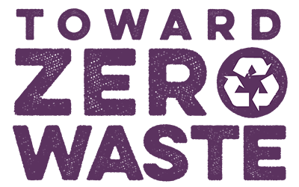

Dear Vendor:
Thank you for your interest in participating at ______ ______________ in _________! We are proud to announce that this event will be a Toward Zero Waste event!

The goal at a Toward Zero Waste event is to plan ahead and distribute only materials that are recyclable or compostable (not any materials that will be landfilled). There will be very few trash cans at the event. Instead, Toward Zero Waste Stations for recycling and composting collection will be available to participants at several locations. Toward Zero Waste events are a great way to not only show our commitment to the environment, but to create a living model of Toward Zero Waste for event participants and the community. As a vendor handing out products at this event, you are the key to the success of our Toward Zero Waste goal.

Vendors attending ______________________ are required to hand out only recyclable or compostable materials to the public. We have included a link to local recycling and composting guidelines with this contract so you can know which types of containers and packaging will be accepted at the Toward Zero Waste stations. Remember, if an item is not recyclable locally, we cannot recycle it, even if your supplier has told you it can be recycled. If you have any questions as to whether your items are considered recyclable or compostable, please call Sanitary Services Company at 360-734-3490 or visit their website http://www.ssc-inc.com/faqs.php for a comprehensive list of what can be composted or recycled.

Our Toward Zero Waste goal is simple to attain if you plan ahead of time for the types of materials you will be providing to the public at the event. Please note that you will be asked to remove any non-recyclable or non-compostable items from your salable products for the duration of the event. Vendors are required to hand out only recyclable or compostable service ware.

Here are some ideas to help you achieve this goal:
- Whenever possible, offer finger foods so as to use fewer utensils. Food items generate a minimal amount of waste for either trash or recycling.
- Consider replacing plastic bowls (for serving chili and soups) with bread bowls and using cones for ice cream. Paper napkins are compostable and can replace bulkier plates. If you must use plates, cups, bowls, cutlery, etc., do not use Styrofoam or plastic.

You must use recyclable or compostable materials in the delivery and/or display of your products. Compostable materials can be purchased easily and locally through the Community Food Coop, Terra Organic & Natural Foods, Cash and Carry and many other local grocery stores. There are many online sources – an example of a good site is www.biodegradablestore.com. They have nearly every product you could possibly need, and multiple quantities available for each product.

We look forward to working with you to make this a successful Zero Waste event. If you have questions regarding Zero Waste, please call XXX-XXX-XXXX

This agreement must be signed and returned to the event planning committee two weeks prior to the event in order for your business to participate.

As a vendor participating in ________________________, I agree to distribute my product in locally recyclable or compostable products. I also agree to sort my discards and make appropriate use of the available Toward Zero Waste stations.

Please send signed contract no later than ________________to:

BUSINESS NAME

______________________________________________________________________________

Employee Name:

(please print)
______________________________________________________________________________
(Signature)

_______________________________________
(date)

_______________________________________
(title)

